**Is name ‘Artem’ popular?**

Hi! My name is Artem… Yes, it’s Russian. And I am from Russia. ‘Artem’ has Russian ‘e’ with two dots on top of the letter (it looks like this ’ё’) and there is no such vowel in English. But it’s not about that. ‘Artem’ is pretty rare name even for Russia. I didn’t meet any other Artems living in Russia for 25 years. Or maybe just couple times but it is so rare so I don’t even remember who it was.

On the other hand, when I came to the US I met 5 Artems in 2 years. One of them became a really close friend to me and the other one is a full double. I mean it. Same name and last name. And he is not even from Russia but from Ukraine.

It was pretty interesting for me and I decided to take a look at ‘Artem’ history in the US. I found an open database with names of babies born in the US from Social Security Administration office ([link](https://www.ssa.gov/open/data/)).

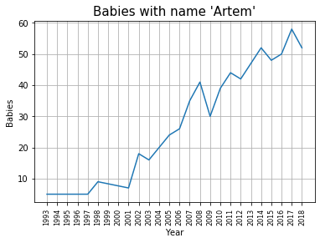

As expected by me there is no babies named ‘Artem’ before 1993. Early 90’s is a time when people from ex-USSR could start to leave their countries and immigrate. We can see an uptrend for name ‘Artem’. But it is not really a growing popularity. It is an increase of immigrants in the US.

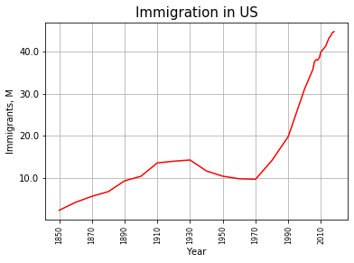

Legal immigration starts to grow in the early 70’s and gets additional boost in the 90’s when USSR collapsed. ([link](https://data.census.gov/cedsci/profile?q=United%20States&g=0100000US&tid=ACSDP1Y2018.DP05))

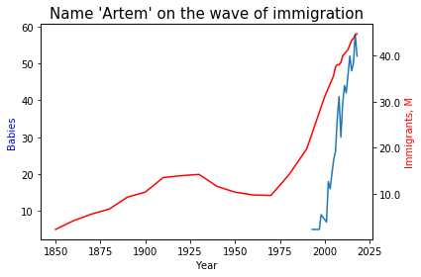

As we can see trend of the name ‘Artem’ corresponds to the trend of immigration in the US.

Well… but is it popular to call your son Artem in the US in the 2018? The chance that a baby boy will be called Artem is just 0.0029% compare to the most popular male name ‘Liam’ which has a change of 1.1%. So every 100th boy was called Liam in the US in 2018.

If Liam is the most popular male name in the 2018 and it is only 1.1% chance that the boy will be called Liam then how many other names are they?

Results are quite impressive:

Unique female names: 18029

Unique male names: 14004

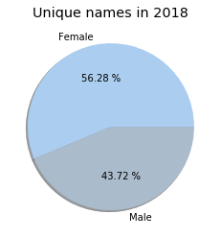

There are more unique names among girls so we can assume that parents who had a girl in 2018 are 12.56% more creative than the parents who had a boy.

To sum up: we realized that me meeting so many Artems in the US is just coincidence because amount of parents who ready to name your son Artem in the US is just 0.0029 %. And all of these Artems that I met are immigrants.